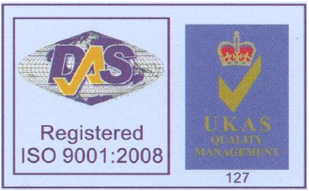

规 格 承 认 书
客户名称 |  | 红外线发射管实图  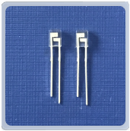  型号：CHQ660/905
业务联系人
联系电话

APPROVED SIGNATURES |  |  | APPROVED SIGNATURES
承办 | 审核 | 核准 | 检测 | 审核 | 核准
PREPARED BY | CHECKED BY | APPROVED BY | TESTED BY | CHECKED BY | APPROVED BY

型号:CHQ660/905
1、Features (特征)
●Lead frame molded packages
引脚框架成型封装
●Two and three or four leads designs
2个或3个或4个引脚设计
●Bi-wavelengths or triple wavelengths LEs
两倍或三倍波长LED
●Matching detector response
匹配探测器响应
2、Applications (应用领域)
●SPO2 血氧饱和度 ● Medical instrumentation 医疗器械
●Blood anaiysis 血液分析 ●Radiometric instruments 辐射仪

Name 名称 | Model型号 | RED | IR | Package
Multiwavelength transmitter 多波长发射器 | CHQ660/905 | 660nm | 905nm | 2-pin,COB

型号:CHQ660/905
Paramete 参数 | Symbol 符合 | Max 最大 | Unit 单位 | Note 标准
Power Dissipation 功率消耗 | Pd | 60 | Mw | …
Forward Current 正向电流 | Lf | 20 | Ma | …
Peak Forward Current 峰值正向电流 | IFP | 100 | Ma | 1/10 duty cycle,0.1ms pulse width 1/10周期, 0.1ms脉宽
Reverse Voltage 反向电流 | VR | 5 | v | …
Operating Temperature 工作温度 | Topr | -25～+85 | ℃ | …
Storage Temperature 储藏温度 | Tstg | -40～+100 | ℃ | …
Soldering Temperature 焊接温度 | Tsol | 260 | ℃ | 260℃ for 3 Secconds
3、Absolute Maximum Ratings (ta=25°)在25°环境下的绝对最大额定参
4、Electrical/Optical Characteristics Ta=25℃(在25°环境下的电性/光学特性)

Parameter 参数 | Symbol 符号 | Min. |  | Typ. |  | Max. |  | Units | Test Conditions 测试条件
Parameter 参数 | Symbol 符号 | IRED | RED | IRED | RED | IRED | RED | Units | Test Conditions 测试条件
Forward Voltage 正向电压 | VF | –– | 1.8 | 1.35 | –– | 1.7 | 2.4 | V | IF=20mA
Reverse Current 反向电压 | IR | –– | –– | –– | –– | 10 | 10 | Ua | VR=5V
Radiant Power 辐射功率 | Po | 1.5 | 9 | –– | –– | 2.5 | 11 | Mw | IF=20mA
Peak Waveiength 峰值波长 | λp |  |  | 905 | 660 | –– | –– | nm | IF=20mA
Spectral Line Half-width半值波长 | Δλ | –– | –– | 50 | 15 | –– | –– | nm | IF=20mA

型号:CHQ660/905
5、Dimension (尺寸)
Notes: 1.All dimensions are in millimeters（尺寸都是以毫米为单位）
2. Tolerances unless dimensions ±0.1mm （未设误差值在±0.1mm）
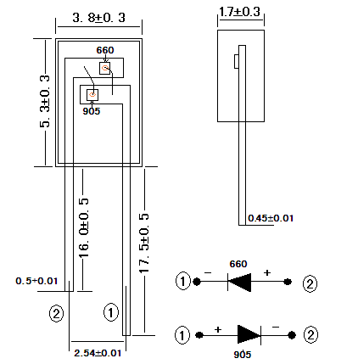
6、Storage and Soldering Condition
1. Do not open moisture proofs bag before the products are ready to use
在产品准备使用前不要打开防潮袋
2. Before opening the package, the LEDs should be kept at 30℃ or less and 90% RH or les
在打开封装之前产品应该保持在30℃或低于30℃和湿温相对度在90%或小于90%的环境中
3. The LEDs should be used within a year.
LED使用期限为1年
4. After opening the package, the LEDs should be kept at 30℃ or less and 70% RH or less.
在打开封装之后，LED应处于30℃或低于30℃和湿温相对度在70%或低于70%的环境中。
5. The LEDs should be used within 168 hours (7 days) after opening the package.
LED应该在打开封装后的168（7天）内使用
6.When soldering, do not put stress on the LEDs during heating.
在焊接加热时不要对LED上施加压力

7. If the moisture adsorbent material (silica gel) has fabled away or the LEDs have
如果湿气吸附剂材料脱落或者LED超过使用时间
exceeded the storage time, baking treatment should be performed using the following
conditions. Baking treatment: 60±5℃ for 24 hours
应在以下条件进行烘烤处理，烘烤处理在60±5°下进行24小时烘烤。
8. After soldering, do not warp the circuit board
在焊接后，不要扭曲电路板。
9. Each terminal is to go to the tip of soldering iron temperature less than 260℃ for 5
每个接口都是在低于焊铁容量25W时，波封焊温度小于260℃，焊接时间持续5秒
seconds within once in less than the soldering iron capacity 25W. Leave tow seconds and
多端口焊接每隔2秒焊接另端口
more intervals, and do soldering of each terminal. Be careful because the damage of the
product is often started at the time of the hand solder.
请小心，因为产品的损坏通常是在手工焊接时容易产生。

